PET ME!
Project Phase #1
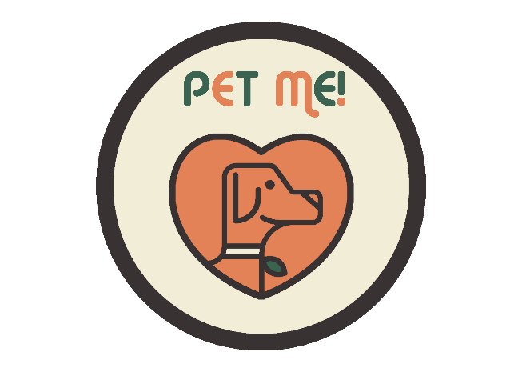

By

Mr. Phumtham Akkarasiriwong 6388001
Mr. Waris Damkham 6388014
Miss Pattanan Korkiattrakool 6388022
Mr. Suphawit Xu 6388078
Mr. Lingwei Kong 6388167
Mr. Wattanapong Sukchareonchok 6388197

A Report Submitted in Partial Fulfillment of
the Requirements for
ITCS335 Introduction to e-Business
Faculty of Information and Communication Technology
Mahidol University
2021
Contents
Topic: PET ME!

Business Detailed 2-9
- Business Description, need that PET ME! wants to solve 2
- Target customers 3-5
- Evidence from the Survey 6
- Why will it be successful? 7
- Features of PET ME! 8
- Revenue Model 9
Competitor 10-15
- Baanlaesuan PETs 10
- S.O. Pet 11
- Pet Backer: Dog Cat Pet Sitting 12
- VitusVet Pet Medical Records 13
- Pet First Aid 14
- Overview 15
SWOT Analysis of your business 16-17
- Strengths 16
- Weaknesses 16
- Opportunities 17
- Threats 17
Business Model Canvas 18
Reference 19

Business Detailed
Business Description
PET ME! is an application to bring comfort for pet owners and their pets. The application provides features and service for pet owners to comprehensive look after of their pets in various ways, whether health concern to shopping for the best product of their pets.

Need that PET ME! wants to solve
- Nowadays, most people start to interest in getting some pets to make their boring ordinary day into a brighter day when they meet their own pets. Absolutely that when pet owners have their own pets, they want to give the best of them to their pets. It might be difficult to take pets to the hospital on certain time because sometimes, the hospital is full of queue with other patients. Consequently, it was wasting of time and was not received medical treatment because the queue was full on that day.
- For example, Sara (pseudonym) has taken her dog to hospital because of skin allergy symptom. Therefore, she must go to the hospital since 7 a.m. to get a queue but veterinarian checked in 9 a.m. due to covid-19 situation which make she feel uncomfortable. So, it makes she wonder that it would better if she can do the online consulting with veterinarian just like in humans’ medical treatment or if she could just book an appointment to take her dog to see the vet in advance at the desired time.

Target customers
- According from some of our interviewee, our target is for people who want to save time taking their pets to the vet.


Demographics
What is your name? | Nichakamol Sukchareonchok, Ice.
How old are you? | 22 years old
What kind of pets do you have? | Cats
Where do you live? You may specify only your province if you wish. | Bangkok
what do you do for work | Studying in college
How many times a month do you give animal care? | 1-2 times per month
Do you think our product will improve your life or make it easier? Please explain | I think it should make caring for my pet easier with its many convenient features.
Do you have any suggestions for our application? | I think it would be nice to add more features.


Demographics
What is your name? | Nadanai Saithong, Tae
How old are you? | 20 years old
What kind of pets do you have? | Cats
Where do you live? You may specify only your province if you wish. | Bangkok, Thailand
what do you do for work | Studying in college
How many times a month do you give animal care? | 1 time per month
Do you think our product will improve your life or make it easier? Please explain | In my opinion it can save our time very much when I use this service because when I take care of them it takes me a whole day.
Do you have any suggestions for our application? | There should be a space for rating each service.



Demographics
What is your name? | Krit Trairat
How old are you? | 21 years old
What kind of pets do you have? | Dogs
Where do you live? You may specify only your province if you wish. | Bangkok, Thailand
what do you do for work | Studying in college
How many times a month do you give animal care? | 3-4 times per month
Do you think our product will improve your life or make it easier? Please explain | It can save my time immensely. The time required for pet services is often time consuming. But it cuts down on those times, freeing up more time to do other things.
Do you have any suggestions for our application? | I wish there was a tutorial in just a few steps so that people who use this app for the first time can use it correctly.
Evidence from the Survey
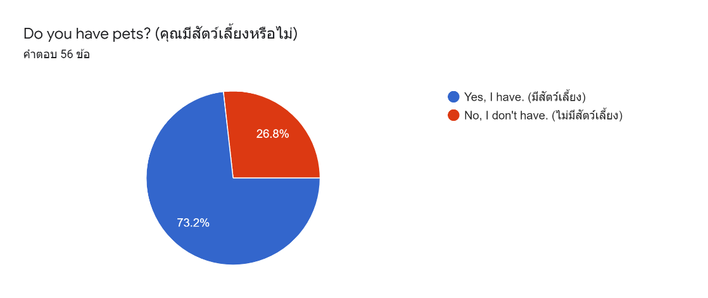

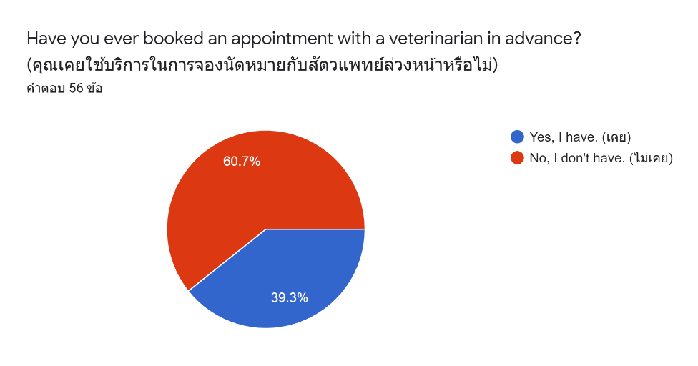
According to the responses to the questionnaire, most people have no experience booking online appointments, and most of the opinions think that waiting in line for treatment during COVID-19 is a waste of time and is uncomfortable for them.
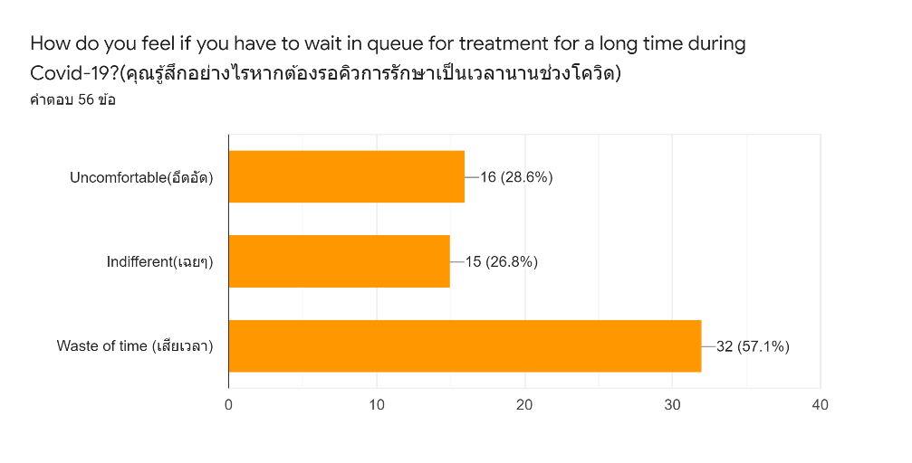

Why will it be successful?

Due to the Covid-19 situation, People probably don't want to sit and wait in line for a long time because besides being uncomfortable, it's also a waste of time. To solve that problem, the PET ME! application is the answer because the application provides a service that makes pet owners, and their pets feel more comfortable. PET ME! provide the service that makes pet owners, and their pets don’t have to wait for a long time in line for medical treatment during the Covid-19. PET ME! has created one function for users (pet owners) to book an appointment in advance with a veterinarian and with hospitals or clinics in which they are interested where they want to take their pets will be treated and be able to select a time that is convenient for users. This function will solve the problem in which wasted their time standing in line. Furthermore, users can look up each veterinarian's education and treatment records. In terms of goods, Pet Me can provide pet supplies and equipment that the buyer may purchase it through a single app. As a result, customers can control their pet's care from a single app. Whether it's about products or services.

Features of PET ME!

PET ME! is service application which contains of 4 functions.

- First, Hospital function – In this function, PET ME! has cooperate with veterinarians, hospital, and clinics to allow user (pet owners) be able to look up each veterinarian's education and treatment records. When users use the hospital function, they can book an appointment in advance in their convenient time. In one condition, users can book an appointment in the available schedule.
- Second, Online Consulting – For Online Consulting is similar with ‘Hospital’ function but difference is that this ‘Online consulting’ is basically a general treatment that focuses on pet behavior problems. User (pet owners) can select whether animal trainers and veterinarians by using our video call mode which costs 150 baht per 15 minutes.
- Third, Transportation – The application has provided friendly driver service. For users to select driver to travel to their destination with their pets whether hospital or other place with a delicious snack for their pets. In term of safety, users can look up to drivers’ personal records and their vaccination history.
- Last, Shopping – In PET ME! ‘s shopping function, we provide best of pet’s food, medicine and equipment with the reliable store and special discount for users (pet owners) to purchase the best and most comprehensive product for their pets.

Revenue Model

PET ME! s’ earn income from 5 channels which are from Hospital, Online consultation, Transportation, Shopping and Advertisement.
- For ‘Hospital’, Every time the user has made an appointment with the hospital or clinic successfully. The hospital or clinic side will have to pay the queue fee to our company in the amount of 15%.
- For ‘Online consultation’, Every time the user has complete the consultation with the veterinarians or pet trainers. The income on Veterinarians and Pet trainers will be deducted as the commission for the company in amount of 15%.
- For ‘Transportation’, Every time the user has arrived at their destination, then driver will receive fare which already deducted in amount of 15% as a commission.
- For ‘Shopping’, In fact, PET ME! has products for animals and medicines that we sell ourselves which is received from an import company that is a partner with our company. Thus, PET ME! will receive profit from that portion. However, there will be a store that opens itself to sell on our application as well. In which we get a monthly commission from those shops and contracts for them.
- Any hospital, clinic, pet supplies store including pet grooming store and pet farms, they can advertise through our application. The fee is charged monthly with a contract signed.

Competitor

- Baanlaesuan PETs

- The Baanlaesuan PETs is an application for pet owner who want to take care of their pets in various ways. This application is suitable for owners who want to read about animals. Whether it's the basics of raising animals drilling into the specifics of species and animal habits disease in pet’s animal behavior including taking pictures of pets.
- There are 5 main features in this application:
1. Homepage – This page is to display owners’ and their pet’s information.
2. Things to know – This page will include interesting information about pets for users to read.
3. Create post – This page is for user to create post for your pet and share an information about them.
4. Directory – This page is key to comprehensive pet care homepage whether pet hospital, pet grooming, pet café, exercise facility for pets.
5. Shopping - This page is for pet owners to purchase pet supplies.

Comparison with PET ME!
– The Baanlaesuan PETs has articles for pet owners to read while PET ME! don’t, but PET ME! has health service for pet and pet owners with hospital and online consulting for pets which this function doesn’t provide in ‘บ้านและสวน PETs’.

- S.O. Pet

- Main function of this application is online consulting with veterinarian not only for ordinary pets but also exotic pets which has 3 prices to choose to pay after the consultation is complete.
- There are 3 plans of online consulting veterinarian which contain of ‘Chat’ 139 baht per 30 minutes, ‘Call’ 159 baht per 20 minutes and ‘Video call’ 179 baht per 20 minutes.
- Pet’s owner can select a specific veterinarian for that type of animal, and they can select to check education and work history of each veterinarian.
- This application also has articles for pet owners, most of the articles are about pet diseases.

Comparison with PET ME!
– The online consulting from S.O. pet has 3 plans for user to select while PET ME! has only one plan which cannot choose. There is one plan called ‘video call’ from S.O.pet which cost 179 baht per 20 minutes in the other hand ‘video call’ from PET ME! costs are 150 baht per 15 minutes also PET ME! has ability to set a constant time schedule for you to select at the time that is most convenient for pet owners with an appointment in advance.

- Pet Backer: Dog Cat Pet Sitting

- An application that connects pet owners to pet services such as grooming, and dog leash which besides the owner, and the furry pets will be well served. It is also had career promotion provided for all animal lovers as well.
- The application comprehensive pet service which contains of pet custody service, daycare for pets, pet walking, pet training and transportation for pet owners, and pets.

Comparison with PET ME!
- The application does not expand to cover all areas, or some stores do not have complete information, furthermore the application does not provide health care service function whilst this function is available in PET ME!

- VitusVet Pet Medical Records

- The application makes it convenient for users to take care of the health of their pets with a well-organized system structure. Just a few pages of filling in all the necessary health information about your pets to assess the health of your pet.
- The application also has veterinarian and other functions for pets, providing pet insurance details, plus noting any allergies or medical alerts for quick reference.
- It is also set up with a to-do list for pet health management, with reminders on everything your pet needs, from giving your pet medication to scheduling appointments to buying food and equipment. Request Appointments and Prescription Refills directly through the app.
- To make an appointment with a veterinarian, the user must first accumulate enough points with the veterinarian to cover the cost of the appointment.

Comparison with PET ME!
– Although VitusVet Pet Medical Records has an advanced appointment service function, to get through to the function, users (pet owners) must gain enough points to make an appointment in advance, whilst PET ME! allows users to use this function without any requirement.

- Pet First Aid

- Google Maps owns this pet application, which includes a pet depository, dog park, dog training center, pet clinic, pet food and supplies store, dog grooming and grooming shop, pet shelter, and pet-friendly hotels.
- This application will be able to locate quickly, including telling the distance to the nearest place, and if it is a pet service facility, you will be able to tap the screen to call the service in the most comfortable way.
- This application may be suitable for users who live in North America, especially the USA and Canada, because it uses databases from that area.

Comparison with PET ME!
– The application is suitable only for users in a specific area, but PET ME! allows users from every area to use the application.

Overview

Comparison map
Features | PET ME! | Baanlaesuan PETs | S.O. Pet | Pet backer: dog cat  Pet sitting | VitusVet  Pet Medial  Records | Pet  First Aid
Book an  Appointment  In advance | 
Online consultation
Shopping
Transportation
New and
Articles
Available on IOS

SWOT Analysis of your business
PET ME! - Customer pains are when the customer must go to the veterinary facility, but there will be no medical treatment schedule because there is only a walk-in line, which creates a long line and wastes time. Pet owners may find waiting in line due to COVID-19 inconvenient.

Strengths
- Strengths are the characteristics that enable us to carry out the mission of the organization. These are the foundations for achieving and maintaining long-term success.
1) Pet Me can help pet owners and their pets feel more comfortable.
2) The customer can schedule a veterinary appointment in a timely and convenient manner.
3) Within the app, customers can select a veterinarian to treat their own pets.
4) Customers may select the hospital where their pet will be treated from within the app. They can view the location of neighboring animal hospitals in the app.
5) Pet Me can pet supplies and equipment, as well as fees from veterinarians and veterinary hospitals, may be offered in two ways that are both profitable.

Weaknesses
- Weaknesses are characteristics that keep us from fulfilling our mission and reaching our full potential. These flaws have a negative impact on the organization's success and growth.
1) Some hospitals are exempt from accepting patients through our app. Because the hospital can already turn a profit on its own.
2) Some consumers don't need to use our app since they live near a veterinarian hospital.
3) In my application doesn't even contact a veterinarian to treat their pets at their homes.
4) Lack of brand recognition, it’s difficult for a new firm to establish itself.

Opportunities
- The environment in which our organization operates presents opportunities. By taking advantage of opportunities, businesses can gain a competitive advantage.
1) The number of people who have pets has increased dramatically in recent years.
2) The average annual number of veterinarian visits per family is high.
3) In today's world, the pet industry's expenditures are on the rise.
4) During Covid-19, sales of pet food and treats increased dramatically.

Threats
- Threats arise when conditions in the external environment endanger the organization's ability to operate reliably and profitably.
1) Many startups are interested in the pet industry.
2) Nowadays, there is more rivalry than ever before.
3) In the pet equipment market, there is a lot of competition.
4) Cost increases, there is always the possibility that business and material costs will rise.

Business Model Canvas
KEY PARTNERS  - Veterinary Hospitals  - Local Veterinary Clinics  - Veterinarians  - Grab Taxi  - Pet food suppliers  - Vetinter group  - Inter Vetta  - BIC CHEMICAL Co., Ltd  - Greatest Pet Care Co., Ltd.  - Tailland Corporation Co., Ltd.  - Wannarak Enterprise Co., Ltd  - ANIMAL-GO-ROUND Co., Ltd. | KEY ACTIVITIES  - Schedule hospital appointment  - Online consulting  - Processing order | VALUE PROPOSITION  - Low cost  - Safety  - Problem-solving  - Improving user’s experience |  | CUSTOMER RELATIONSHIP  - Call center  (Online Consulting)  - Promotion and discount coupon  - Online inquiry  - Dedicated personal assistance | CUSTOMER SEGMENTS  - Pet owners  - Pet lovers
 | KEY RESOURCES  - Veterinary Hospitals  - Veterinary Clinics  - Veterinarians  - Taxi  - Pet food suppliers  - Pet medical suppliers  - Pet accessory suppliers  - Pet equipment suppliers |  |  | CHANNELS  - E-commerce  - Application  - Word of mouth  - Social Media | CUSTOMER SEGMENTS  - Pet owners  - Pet lovers
COST STRUCTURE  - Platform and application development  - Software Maintenance |  |  | REVENUE STREAMS  - Brokerage fee  - Free  - Freemium  - In-app purchase

Reference

[1] “Get pet sitters for cat sitting & dog home boarding,” PetBacker. [Online]. Available: https://www.petbacker.com/
[2] Pets บ้านและสวน, “16 แอปพลิเคชันสำหรับคนรักสัตว์เลี้ยง ที่น่าโหลดเก็บไว้ติดเครื่อง - บ้านและสวน pets,” บ้านและสวน, 04-May-2021. [Online]. Available: https://www.baanlaesuan.com/184655/pets/lifestyle-pets/application-for-pets
[3] “ข้อมูลการดูแลสัตว์เลี้ยง จากทีมผู้เชี่ยวชาญ บ้านและสวน pets,” บ้านและสวน. [Online]. Available: https://www.baanlaesuan.com/pets
[4] “Vitusvet,” VitusVet, 20-Sep-2021. [Online]. Available: https://vitusvet.com/
[5] “Consult veterinary online,” SOPet. [Online]. Available: https://sopet.co/en

